

WD

**HTML - Full stack and Back end**



August 31, 2023

KULBHUSHAN UPADHYAY

**Q. Are the HTML tags and elements the same thing?**

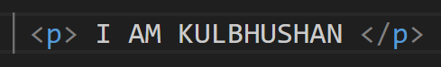**Ans**. No, HTML tags and elements are not the same things.

example:

This <p> is called a TAG. Tags are always written between Angle brackets (< >). (<p> is called the starting tag, and </p> is called the closing tag or end tag), and I am Kulbhushan, this is a content. Tags and Content combine to form an ELEMENT.

**Q. What are tags and attributes in HTML?**

**Ans**. Tags are used to create HTML documents and describes web documents (Web Pages), such as <b>, <p>, <h1> to <h6>, and many more. Each HTML tags describes different document content. HTML tags normally come in pairs. (<p>…. </p>).

An attribute is used to provide additional information about HTML elements, like images and adding links, and it’s also used to give additional information about the content, like height, width, font size, etc. It is always written in the first tags (Starting tag). Attributes carry a value in =" " but some attributes not a carry value like Required, Checked etc...

*Example:*



In this example, href is an attribute that carries a link, and its output is Swiggy. When you click on Swiggy in the output, the page opens Swiggy’s website.

**Q. What are void elements in HTML?**

**Ans**. Void elements are non-closing tags in HTML. It is also known as self-closing tags. Normally, void elements also have attributes.

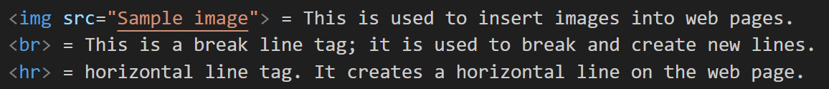Some examples =

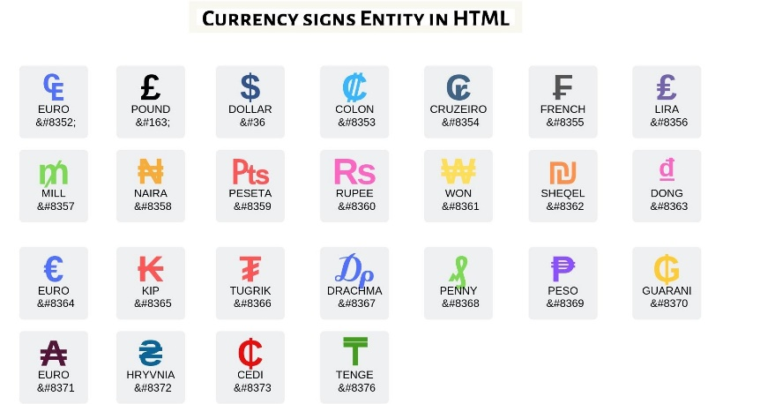 **Q. What are HTML Entities?**

**Ans**. HTML entities are one type of special character that is not available on our keyboard but is used in HTML documents and different websites. Each entity has a particular number or code. HTML entities allow you to add symbols, math symbols, and geometric shapes. **that begins with an ampersand (&) and ends with a semicolon (;).** These are some HTML entities.

**Q. What are different types of lists in HTML?**

**Ans**. List tag are used for making list for list content like Menu. list is a record of information’s

There are three type of list tag :

1) Order List (<ol >): Order lists are used for making sequence lists mainly with numbers and also using capital and small alphabets or roman numbers. Ordered lists are created using the <ol> tag, and then items are listed using the <li> tag in between the <ol> & </ol> tags.

2) Unordered List (<ul>): In unordered lists, items are usually marked with bullets. Unordered lists are created using the <ul> tag, and then items are listed using the <li> tag in between the <ul> & </ul> tags.

3) Define List (<dl>): Define List is used to give a definition or description to a specific term on a web page. Define lists are created by < dl>, definitions are written with <dt> &</ dt>, and define descriptions are created by <dd> </dd>. Both are <dt> & <dd>, written in between <dl> & </dl>.

  In Put = LIST TAGS EXAMPLE =

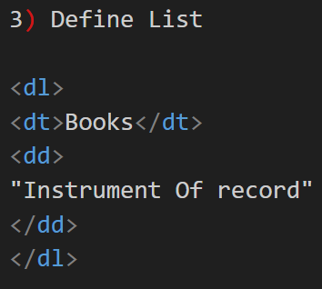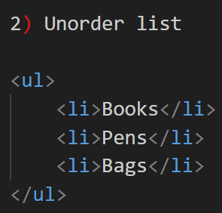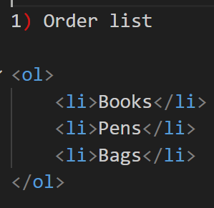

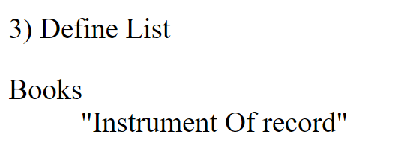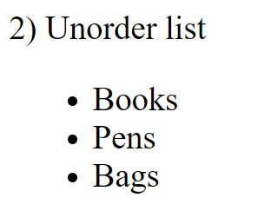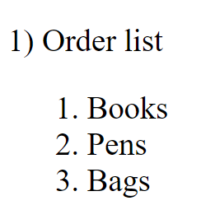 Out Put =

**Q. What are the various formatting tags in HTML?**

**Ans**. Formatting tags used for text to improve its look and feel. Formatting tags allows you to format tags without using CSS. These tags are used to make text bold, italicized, or underlined. These are some type of formatting tags in HTML.

Example =

* <i> : Makes Text Italic (Also use <em>).
* <b> : Makes Text Bold (Also use <strong>).
* <u> : Makes Text Underline.
* <sub> : Display Text as a Subscript.
* <sup> : Display Text as a Superscript.
* <big> : Makes Text to bigger in size.
* <small> : Makes Text to smaller in size.
* <mark> : Marked text with background yellow color.

**Q. How is Cell Padding different from Cell Spacing?**

**Ans**. Cell padding is used for spacing between content (text) and cells, and cell spacing is used for spacing between cells and table borders.

Cell spacing and cell padding are table attributes that are used in HTML tables. To manage spacing between content, cells, and tables.

**Q. How can we club two or more rows or columns into a single row or column in an HTML table?**

**Ans**. **We** club two or more rows or columns into a single row or column in an HTML table by using colspan and rowspan.

When clubbing two or more rows, use colspan. When clubbing two or more columns, use rowspan in an HTML table. Rowspan and colsapn are both attributes for table tags. Attribute values are always numerical.

**Q. What is the difference between a block-level element and an inline element?**

**Ans**. **Block elements in HTML start with a new line, occupy the complete horizontal space, and have the same height as the content. At the same time, inline elements in HTML do not start on a new line and occupy space as required.**

Block-level elements = <h1> to <h6>, <p>, <blockquots>, <ul>, <ol>, <li>, <hr> etc…

Inline elements = <b>, <img src=””>, <span>, <i>, <a>, etc…..

**Q. How to create a Hyperlink in HTML?**

**Ans**. Hyperlinks are created in HTML using the anchor tag (<a href=""> < /a>), and the link is added to the href value. "href" is an attribute, and value is a link.

Example =

**Q. What is the use of an iframe tag?**

**Ans**. The iframe tag is used to add video, audio, and documents from another web page to our web page. Using the embed (Share Feature) feature, the other content attached to our webpage. An inline frame is used to embed another document within the current HTML document.

Example: An iframe is allowed to change height, width, border, etc. All are attributes for an iframe.

**Q. What is the use of a span tag? Explain with example?**

**Ans**. The span tag has both open(<span>) and closing (</span>) tags, and it is mandatory to close the tag. The span tag is used to give style to a particular portion of the content.

Example =



OUTPUT =



**Q. How to insert a picture into a background image of a web page?**

**Ans**. To insert a picture into the background image of a web page, we need to set "background-image" in CSS.

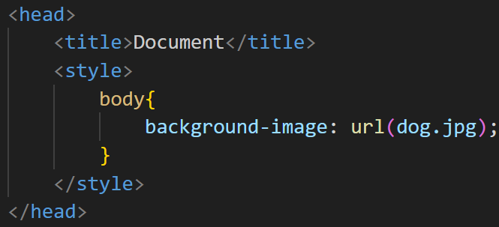Example =

**Q. What are the different tags to separate sections of text?**

**Ans**. There are many tags to separate sections of text. Some as examples

* <h1> to <h6> (Heading Tags): These tags are used to separate headings.
* <p> (paragraph tag): The <p> tag separates content on the web page into different sections.
* <hr> (horizontal line): This tag is also helpful for separating text on the web page with a horizontal line.
* <li> (List tag): this tag makes a new line for content.
* <br> (break line): The brake line makes space between two content
* <div> (Division): Creates a new division

**Q. What is SVG?**

**Ans**. SVG : Scalable Vector Graphic. (<svg> </svg>) SVG is used for making graphic in web page like Square, Rectangle, polygon etc..

**Q. What is difference between HTML and XHTML?**

**Ans**. HTML = Hypertext Mark-up Language & XHTML = Extensible Hypertext Mark-up Language are both mark-up languages and used to create structure of a web page and HTML documents.

HTML is not case sensitive you can use uppercase for tags and attributes (<p> & <P>).

XHTML is case sensitive so tags are compulsory in lowercase (<p>).

**Q. What are logical and physical tags in HTML?**

**Ans. Logical tag:** Logical tags are used only to give information about the text written in the HTML pages. Logical tags are used for a better result on a web page.

Example: <strong></strong> tag. This “strong” tag implies that the text is of great importance. Such tags are used by search engines to understand the page for better search results. <div>, <span> etc…

**Physical tags:** On the other hand, provide specific instructions on how to display the text they enclose.

Example:

### <b>: makes the text bold.

<big>: Makes the text usually one size bigger.

<i>: Makes text italic.

**Pending Questions because CSS class is not done.**

1. What is the ‘class’ attribute in HTML?
2. What is the difference between the ‘id’ attribute and the ‘class’ attribute of HTML elements?
3. How are active links different from normal links?